CANTERBURY ENGLAND ULTIMATE XV – ALEX AND EMMA-LOUISE BOX,
MARRIED COUPLE AND ENGLAND FANS
It’s fitting that Twickenham is heaven for England fans, because Alex and Emma-Louise Box are a marriage made there – quite literally.
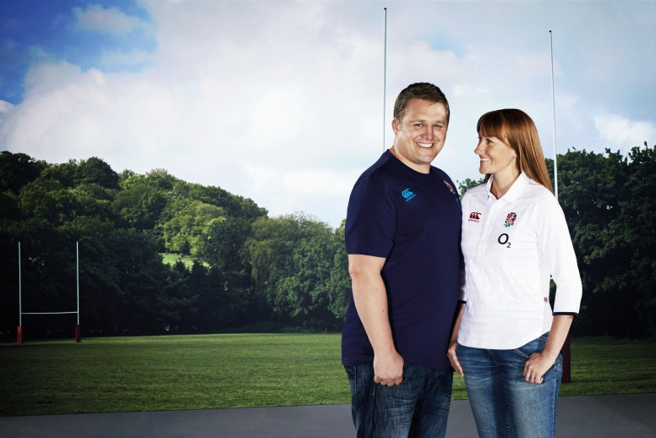
England Rugby’s HQ was the setting for the pair’s nuptials in 2011, with Emma-Louise even using the England dressing room to change into her dress ahead of the ceremony.
It was on their honeymoon, though, where the couple really rose to prominence among their fellow supporters. After flying to New Zealand for a dream eight week trip to enjoy the Rugby World Cup, the pair ensured they stood out from the crowd by wearing their full wedding finery to every England game.
“Taking two months unpaid leave from work was a huge project to pull off”, Alex recalled, “but worth every penny and hassle!”
Alex was the driving force behind their mutual love of rugby. Emma said: “When I met Alex I knew a bit about the game and followed it occasionally but he helped me develop my love and understanding of it.”
However, Emma also helped Alex to recapture his love of playing the game. “When we first met 12 years ago, I had stopped playing rugby, due to work and family commitments. But Emma pushed me back into it and I could not dream of not playing now!”
Prior to meeting, Emma, Alex also credits the other woman in his life, his mum, as being one of the main driving forces behind his passion for rugby. “I’d watch rugby with her as she screamed unprintable abuse at the Aussies on our little kitchen television,” recalls Alex. “She also used to provide the taxi service every week to training and matches.”
One thing that becomes apparent when speaking to the couple is their sheer love of the game, and when asked what it means to them, Alex was unequivocal in his response: “Rugby is family. Because family is about being together, looking after each other, having fun together, getting through adversity together, achieving something together. Being part of my rugby club feels just like that. Rugby is a true team sport, the only way to win is to do it together.”
It’s a view shared by his wife: “Rugby isn’t just a sport, it’s a way of life. It teaches you so many valuable lessons; the value of working as a team and how individual contributions can get the team to their final goal; how to face adversity and come out a stronger person; the respect; the passion; the pride. These are skills that you carry on into your life and help you to become a better person.
As for the wedding outfits, don’t think you’ve seen the last of them just yet…
“We plan to go to Twickenham wearing the wedding outfits again for an ‘anniversary’ of sorts. We are also planning for an ‘anniversary’ trip around England in 2015 and Japan in 2019.”

